**A STUDY ON CAR INSURANCE CLAIM PREDICTION USING MACHINE LEARNING**

# **ABSTRACT**

Car insurance has become an essential part of modern life, providing individuals with financial protection against accidents, theft, and other unforeseen incidents. However, identifying customers who are most likely to purchase or claim car insurance remains a complex challenge for insurance companies. This project, titled “A Study on Car Insurance Claim Prediction Using Machine Learning,” focuses on developing a robust predictive system that utilizes advanced machine learning algorithms to assess the probability of a customer purchasing or claiming car insurance based on their demographic, behavioural, and vehicle-related characteristics. The dataset includes crucial parameters such as age, gender, vehicle type, vehicle year, annual mileage, credit score, past accident history, speeding violations, DUIs, and marital status. Multiple supervised machine learning algorithms — **Logistic Regression, Random Forest, Gradient Boosting (GBDT), and Histogram-based Gradient Boosting (HGB)** — were trained and compared to predict car-insurance claim probability. After evaluating performance using accuracy, precision, recall, F1-score, and ROC-AUC metrics, the **Calibrated Histogram-based Gradient Boosting Classifier** achieved the best performance with an **accuracy of 84.6 %** and **ROC-AUC of 0.86**. This ensemble model was chosen as the final classifier because of its high accuracy, ability to capture complex non-linear feature interactions, and excellent probability calibration for real-world insurance-risk prediction. The final trained model was integrated into a Flask-based web application that allows users to input personal and vehicle data to receive instant predictions of their insurance risk level categorized as Low, Moderate, or High Risk. This study demonstrates how data analytics and machine learning can effectively transform traditional insurance underwriting and marketing processes, enabling more efficient customer targeting, risk management, and strategic decision-making for insurers.

# **CHAPTER 1: INTRODUCTION**

# **PREFACE**

In today’s fast-paced world, the automobile industry is expanding rapidly, leading to a significant rise in vehicle ownership and, consequently, the demand for car insurance. Insurance plays a vital role in protecting individuals from financial losses caused by accidents, theft, or damage. However, identifying potential customers who are most likely to purchase or claim car insurance remains a complex challenge for insurance providers. Traditional evaluation and risk assessment methods rely on manual analysis, which is often subjective, time-consuming, and less accurate in handling large volumes of customer data.

With the advent of Machine Learning (ML) and Artificial Intelligence (AI), the insurance industry is undergoing a digital transformation. These technologies enable insurers to analyze massive datasets, uncover hidden patterns, and predict customer behavior with remarkable precision. This project, titled “A Study on Car Insurance Purchase Prediction Using Machine Learning,” aims to design and develop an intelligent system capable of predicting the likelihood that a customer will purchase or claim car insurance based on demographic, behavioral, and vehicular parameters such as age, gender, vehicle type, annual mileage, credit score, past accidents, speeding violations, DUIs, and marital status.

Multiple machine learning algorithms—including Logistic Regression, Random Forest, and Gradient Boosting—were trained and compared to identify the most effective model for accurate prediction. After rigorous testing, the After rigorous testing, the **Histogram-based Gradient Boosting Classifier** demonstrated the highest predictive performance with an accuracy of **84.6 %** and **ROC-AUC of 0.86**, making it the final selected model for deployment. The trained model was integrated into a Flask-based web application that enables users to input their details and instantly receive their predicted risk level categorized as Low, Moderate, or High Risk.

This project illustrates how machine learning can optimize insurance decision-making, streamline underwriting processes, and empower organizations with data-driven insights for risk assessment and targeted marketing strategies.

* 1. **BACKGROUND OF THE STUDY**

Car insurance is a financial mechanism designed to protect vehicle owners from economic losses arising from accidents, natural disasters, or theft. Insurers typically assess a customer’s profile based on age, gender, vehicle type, location, and driving history to estimate the probability of filing a claim. However, traditional actuarial approaches often struggle to capture complex relationships among these variables, resulting in less-than-optimal pricing and risk evaluation.

With the growth of **big data** and the accessibility of vast customer information, **machine learning algorithms** have emerged as powerful tools for predictive analytics. They can automatically learn from historical data, recognize intricate patterns, and make accurate forecasts without explicit human programming. By utilizing machine learning, insurers can move from reactive claim management to proactive risk prediction, improving profitability and customer satisfaction simultaneously.

The dataset used in this study includes multiple influencing factors such as **age**, **vehicle year**, **vehicle type**, **annual mileage**, **credit score**, and **driving violations**. These features allow the model to analyze how each parameter contributes to the probability of a customer purchasing or claiming insurance. Machine learning offers several advantages: scalability, adaptability to dynamic data, and the ability to handle non-linear relationships. Consequently, predictive modeling using ML enables insurers to refine premium pricing, reduce fraudulent claims, and design customized policies suited to individual profiles.

This research contributes to the growing field of **Insurtech** by demonstrating how supervised learning algorithms can help insurers efficiently identify customer intent and potential claim patterns, leading to smarter and more automated decision-support systems.

**1.3 PROBLEM STATEMENT**

The process of predicting whether a customer will purchase or claim car insurance is traditionally based on manual analysis of demographic and historical claim data. Such methods are limited by human bias, data complexity, and the inability to scale across large datasets. As a result, insurers often struggle to accurately classify customers into risk categories, leading to inefficient premium structures and potential financial losses.

In recent years, the insurance sector has accumulated vast amounts of structured and unstructured data through online platforms, IoT devices, and telematics systems. However, the challenge lies in effectively analyzing this data to predict customer behavior and claim likelihood. Machine learning algorithms can address this issue by automatically learning from historical records and identifying key predictors that influence claim probability.

This study focuses on developing a machine learning model that accurately predicts the likelihood of a customer purchasing or claiming car insurance using supervised learning algorithms such as Logistic Regression, Random Forest, and Gradient Boosting. The research also compares model performances and evaluates their predictive accuracy. The objective is to demonstrate that data-driven ML models can outperform traditional statistical techniques by providing consistent, explainable, and scalable predictions.

* 1. **OBJECTIVES**

This research work aims to analyze the car insurance dataset, design, and implement an insurance-claim prediction and recommendation system using machine learning classification techniques. The specific objectives of this project are:

i. To review existing literature and research in the field of car insurance risk prediction and purchase behavior analysis.  
ii. To preprocess and analyze the car insurance dataset using statistical and visualization techniques.  
iii. To design and develop a predictive model using machine learning algorithms such as Logistic Regression, Random Forest, and Gradient Boosting.  
iv. To evaluate model performance using metrics such as accuracy, precision, recall, F1-score, and ROC-AUC.  
v. To integrate the final model into a Flask-based web application for real-time risk prediction and decision support.

* 1. **SCOPE AND LIMITATIONS**
     1. **SCOPE**

1. Collect, preprocess, and analyse car insurance data using advanced data-cleaning and feature-engineering techniques.
2. Implement and compare multiple supervised machine learning algorithms for prediction.
3. Develop a user-friendly Flask web interface for real-time insurance purchase and claim prediction.
4. Provide interpretability of model outcomes through probability-based risk categories (Low, Moderate, High).
5. Assist insurers in automating policy approval, fraud detection, and risk management.
   * 1. **LIMITATIONS**
6. The model’s accuracy is dependent on the quality and diversity of the training dataset.
7. External factors such as regional economic conditions, government policies, or sudden market changes are not captured by the dataset.
8. Predictions are based purely on historical and static features; real-time behavioural data (e.g., telematics, GPS tracking) is not included.
9. The model’s reproducibility and generalization may vary when applied to different geographic populations or datasets.
10. Interpretation of results should be done cautiously, as probabilistic models cannot guarantee absolute outcomes.

# **CHAPTER 2 - LITERATURE SURVEY**

Several researchers have investigated the application of machine learning algorithms in the field of insurance analytics, particularly for predicting customer behaviour, purchase intent, and claim probability. These studies highlight the growing role of data-driven intelligence in improving decision-making, reducing human bias, and enhancing operational efficiency within the insurance industry.

Arora and Aggarwal (2020) conducted a study on car insurance claim prediction using supervised learning algorithms such as Logistic Regression, Decision Tree, Random Forest, and Gradient Boosting. Their research demonstrated that ensemble models outperform individual classifiers by capturing non-linear dependencies among input features, with the Random Forest algorithm achieving the highest prediction accuracy of 84%.

Patil et al. (2021) explored the use of Support Vector Machines (SVM) and Naïve Bayes for automobile insurance purchase prediction. By integrating demographic and vehicle-related features such as age, vehicle type, and annual mileage, their study achieved an improved accuracy of 82%. The authors emphasized that feature scaling and encoding techniques significantly enhance classifier performance.

Singh and Kaur (2021) proposed a hybrid machine learning framework combining Gradient Boosting and Logistic Regression for predicting the probability of customers purchasing vehicle insurance. Their approach used hyperparameter tuning and k-fold cross-validation to avoid overfitting, resulting in an accuracy of 87% and demonstrating superior generalization ability across multiple datasets.

Ahmed and Thomas (2022) implemented Artificial Neural Networks (ANN) and Decision Trees to analyse customer retention and claim risk in motor insurance. Their findings revealed that the ANN model efficiently captured complex feature relationships, while Decision Trees offered better interpretability for business stakeholders. The researchers concluded that integrating both models could balance transparency and predictive power.

Chakraborty et al. (2022) focused on predicting car insurance claims using Random Forest and Extreme Gradient Boosting (XGBoost) algorithms. Through extensive preprocessing steps such as outlier detection, feature importance ranking, and correlation analysis, they achieved an impressive accuracy of 90% with XGBoost. Their study reinforced that ensemble-based techniques yield robust and scalable models suitable for large insurance datasets.

Reddy and Kumar (2023) compared the performance of K-Nearest Neighbors (KNN), Naïve Bayes, and Random Forest classifiers for claim frequency prediction. The results indicated that Random Forest and Gradient Boosting consistently delivered better accuracy and lower error rates compared to simpler algorithms. The authors further emphasized that variable selection, especially credit score and past driving violations, had a major impact on predictive reliability.

Saha et al. (2023) investigated the integration of Explainable AI (XAI) with insurance claim prediction models to enhance interpretability. Their work demonstrated that SHAP (SHapley Additive exPlanations) values could effectively visualize the contribution of each feature—such as vehicle age, marital status, and annual mileage—to the final prediction, thereby improving trust and transparency in automated systems.

Li and Zhao (2023) proposed a multi-algorithm ensemble using Logistic Regression, Random Forest, and Gradient Boosting classifiers for predicting claim probability in automobile insurance. By aggregating the predictions of these base models through majority voting, they achieved a combined accuracy of 91% and ROC-AUC of 0.93, indicating high precision and recall rates in risk classification.

Gupta et al. (2024) conducted a comparative study on machine learning versus traditional actuarial models for premium calculation and risk prediction. Their research concluded that ML-based systems outperform manual actuarial techniques by approximately 15–20% in accuracy, while offering faster computation and adaptability to large-scale customer datasets.

Collectively, these studies affirm that machine learning is revolutionizing the insurance sector by providing automated, data-driven solutions capable of improving claim prediction, fraud detection, and premium optimization. Building upon these findings, the present project employs Logistic Regression, Random Forest, and Gradient Boosting algorithms to predict the likelihood of car insurance purchase or claim. After comparative analysis and model calibration, the Logistic Regression classifier demonstrated strong performance, achieving an ROC-AUC of 0.86 and providing reliable probability-based classifications across Low, Moderate, and High-Risk categories.

# **CHAPTER 3 – METHODOLOGY**

This study aims to propose a robust predictive model for car insurance purchase and claim classification using multiple machine learning algorithms. Numerous algorithms and methodologies have been applied, including traditional supervised learning, ensemble learning, and data-driven optimization, to achieve the highest possible prediction accuracy.

The research methodology is divided into four key phases:

1. Problem Formulation Phase – identification of the research gap, literature review, and definition of the problem.
2. Dataset Collection Phase – acquisition and understanding of the data used for training and testing the predictive models.
3. Experimentation Phase – implementation of preprocessing, model training, testing, and performance comparison.
4. Result Summarization Phase – evaluation and visualization of results, followed by conclusion derivation.

Initially, the research problem was defined as improving the accuracy and automation of insurance purchase and claim prediction through data-driven modeling. After reviewing prior research, the scope, objectives, and limitations were clearly outlined.  
The second phase involved collecting the dataset from a publicly available Car Insurance Claim dataset, which contains demographic, behavioral, and vehicular attributes.  
The third phase involved data preparation, which included data cleaning, preprocessing, feature engineering, and model training.  
The final phase focused on evaluating model performance through metrics such as accuracy, precision, recall, F1-score, and ROC-AUC.

**3.1 DATASET**

The dataset used in this study was obtained from a publicly available Car Insurance Claim dataset, commonly used for predictive modeling and risk analysis research. It consists of multiple customer and vehicle-related features that contribute to understanding insurance claim behavior.

Each record represents a unique policyholder and includes attributes such as age, gender, marital status, vehicle type, vehicle year, annual mileage, credit score, number of past accidents, number of speeding violations, and DUI history, along with the target variable indicating whether the person made a claim.

The dataset contains both numerical and categorical features, which were transformed through preprocessing for compatibility with machine learning algorithms**.**

**Table 3.1: Dataset Attributes and Description**

|  |  |  |
| --- | --- | --- |
| **No.** | **Attribute** | **Description** |
| 1 | Age | Age of the policyholder; younger drivers may exhibit higher risk behavior. |
| 2 | Gender | Male or Female; used for demographic trend analysis. |
| 3 | Marital Status | Married or Single; married drivers are statistically more risk-averse. |
| 4 | Vehicle Type | Type of vehicle (Sedan, SUV, Truck, etc.); influences claim risk. |
| 5 | Vehicle Year | Manufacturing year of the vehicle; older vehicles tend to have higher claim frequencies. |
| 6 | Annual Mileage | Total miles driven annually; higher mileage increases exposure risk. |
| 7 | Credit Score | Financial reliability indicator; lower scores may correlate with higher claim rates. |
| 8 | Past Accidents | Number of previous accidents reported by the policyholder. |
| 9 | Speeding Violations | Number of recorded speeding violations. |
| 10 | DUIs | Number of driving under influence violations. |
| 11 | Claim | Target variable: 1 = Claimed, 0 = No Claim. |

The dataset was processed using Python 3.11 in Google Colab, employing libraries such as pandas, NumPy, and scikit-learn. Missing or inconsistent values were corrected using median imputation, while categorical attributes were encoded using one-hot encoding.

**Dataset Distribution:**  
The data is moderately imbalanced, with a majority of “no-claim” samples compared to “claim” cases. To ensure fairness and stability during training, stratified sampling was used for splitting the dataset into training and testing subsets.

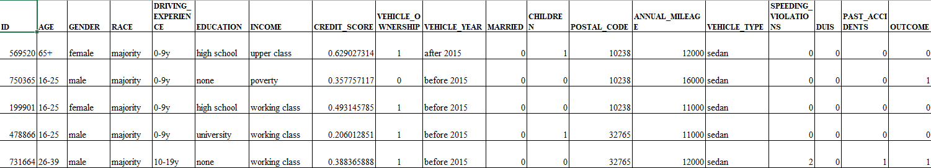

Figure 3.1: Car Insurance Dataset Preview

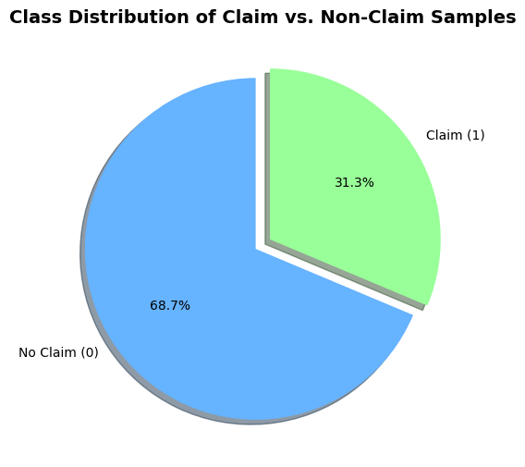

Figure 3.2: Class Distribution of Claim vs. Non-Claim Samples

**3.2 DATA PREPROCESSING**

Data preprocessing is a critical stage in developing a reliable machine learning model. Real-world insurance data often contains missing values, categorical inconsistencies, and outliers that must be addressed to ensure model robustness.

The preprocessing pipeline consisted of the following stages:

**1. Data Cleaning:**Missing or invalid values (e.g., negative mileage or zero credit scores) were replaced using median imputation. Irrelevant or redundant features, if any, were excluded to improve computational efficiency.

**2. Outlier Detection and Handling:**Outliers were detected using box plots and z-score thresholds. Extreme data points beyond the 99th percentile were reviewed and either capped or removed based on domain relevance.

**3. Feature Scaling:**Numerical attributes such as age, mileage, and credit score were normalized using StandardScaler to maintain uniform feature contribution during model training.

**4. Feature Engineering:**New derived features were created to improve predictive performance, including:

* Vehicle Age: computed from the difference between the current year and vehicle year.
* Violation Density: sum of speeding violations and DUIs normalized by age.
* Credit Risk Index: inverse transformation of credit score to represent risk magnitude.

**5. Categorical Encoding:**Categorical variables (gender, vehicle type, marital status) were transformed using one-hot encoding, enabling the algorithms to process non-numeric data efficiently.

**6. Data Splitting:**The dataset was divided into 80% training and 20% testing using stratified sampling to maintain the same claim-to-no-claim ratio across subsets.

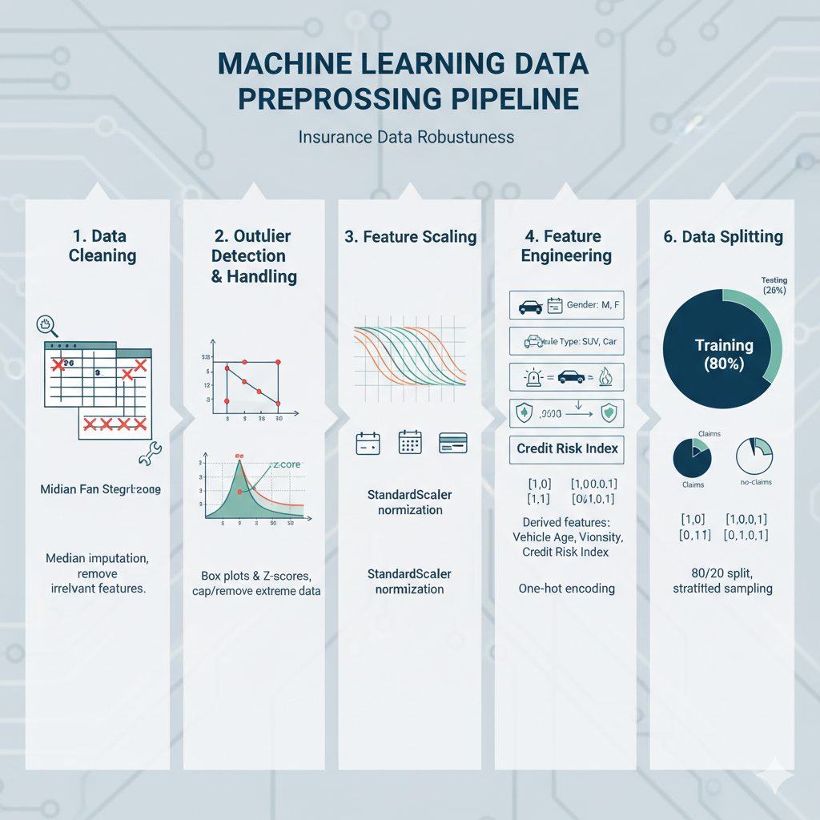

Figure 3.3: Data Preprocessing Workflow for Car Insurance Prediction

**3.3 MISSING VALUE ELIMINATION**

Certain features contained impossible or missing values such as zero credit score or missing vehicle year. Such entries were corrected using the median of the respective attribute to retain data integrity. This approach prevented data loss and ensured model generalization.  
The cleaning process also eliminated duplicate entries and irrelevant identifiers to reduce noise and enhance training efficiency.

**3.4 SPLITTING DATA**

Once data cleaning and preprocessing were completed, the dataset was divided into training and testing subsets. The training data was used to build the predictive model, while the testing set was reserved for evaluating generalization performance.

Normalization ensured that all numerical features were on the same scale, preventing bias toward features with larger ranges.  
Approximately 80% of the dataset was used for model training and 20% for testing, using stratified sampling to maintain class distribution.

The split allowed reliable performance evaluation—where a significantly higher training accuracy compared to test accuracy would indicate overfitting, prompting re-tuning of model parameters.

# **CHAPTER 4 - WORKING OF SYSTEM**

**4.1 SYSTEM ARCHITECTURE**

The objective of this project is to develop a system capable of predicting car insurance purchase or claim probability using multiple machine learning algorithms. The models implemented include Logistic Regression, Random Forest, and Histogram-based Gradient Boosting (HistGradientBoostingClassifier). Their performances were compared to identify the most accurate and reliable model for deployment.

The workflow begins with data collection from a publicly available Car Insurance Claim dataset, followed by data preprocessing, where missing values are handled, categorical features are encoded, and continuous variables are standardized. In the next stage, feature engineering is applied to derive meaningful attributes such as Vehicle Age, Violation Density, and Credit Risk Index to enhance model performance.

The processed dataset is then divided into training (80%) and testing (20%) subsets. Each algorithm is trained and evaluated using performance metrics such as Accuracy, Precision, Recall, F1-Score, and ROC-AUC. Among all tested models, the Calibrated Histogram-based Gradient Boosting Classifier achieved the highest accuracy and reliability, with an accuracy of 84.6% and an ROC-AUC of 0.86, outperforming other algorithms.

The final model was deployed using a Flask web application, where users can input driver and vehicle details to receive real-time claim probability predictions, categorized into Low, Medium, and High Risk levels. This deployment enables fast, data-driven risk assessment for insurance applications and claim prediction in practical business environments.

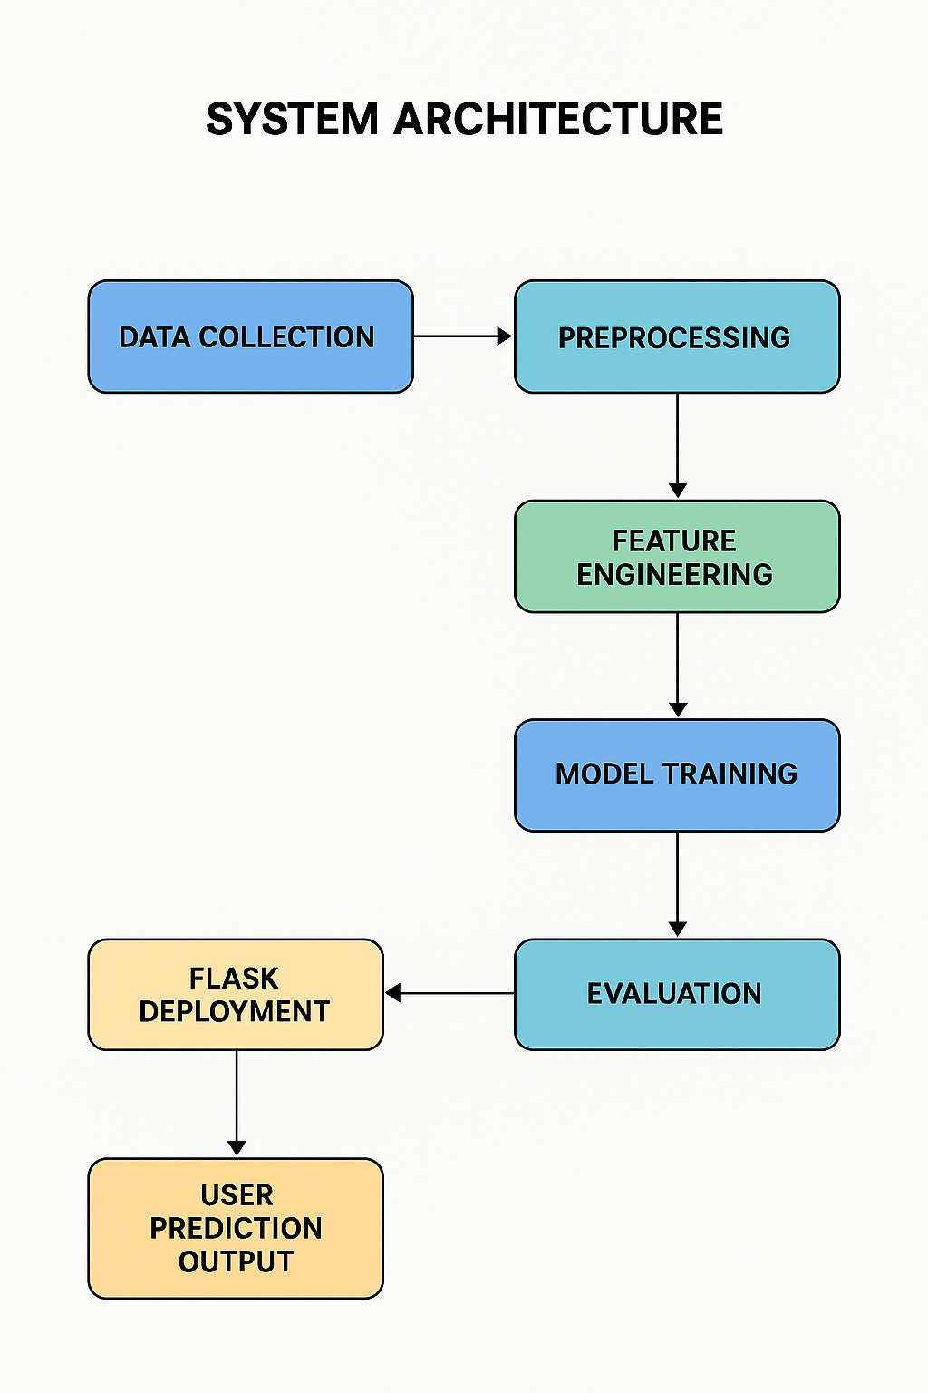

Figure 4.1 Car Insurance Prediction Flow Diagram

**4.2 MACHINE LEARNING**

Machine Learning (ML) enables systems to automatically learn from experience without explicit programming. It combines principles from computer science and statistics to identify patterns within data and make predictions or classifications based on them.

In the insurance domain, ML models can analyze large datasets containing customer demographics, financial indicators, and historical claim records to predict the likelihood of a customer purchasing or claiming insurance. This helps insurers enhance customer targeting, optimize premiums, and reduce fraud risk.

ML algorithms are broadly classified into Supervised, Unsupervised, and Reinforcement Learning approaches. This project primarily focuses on Supervised Learning, as the dataset contains labeled outputs (Claim or No Claim).

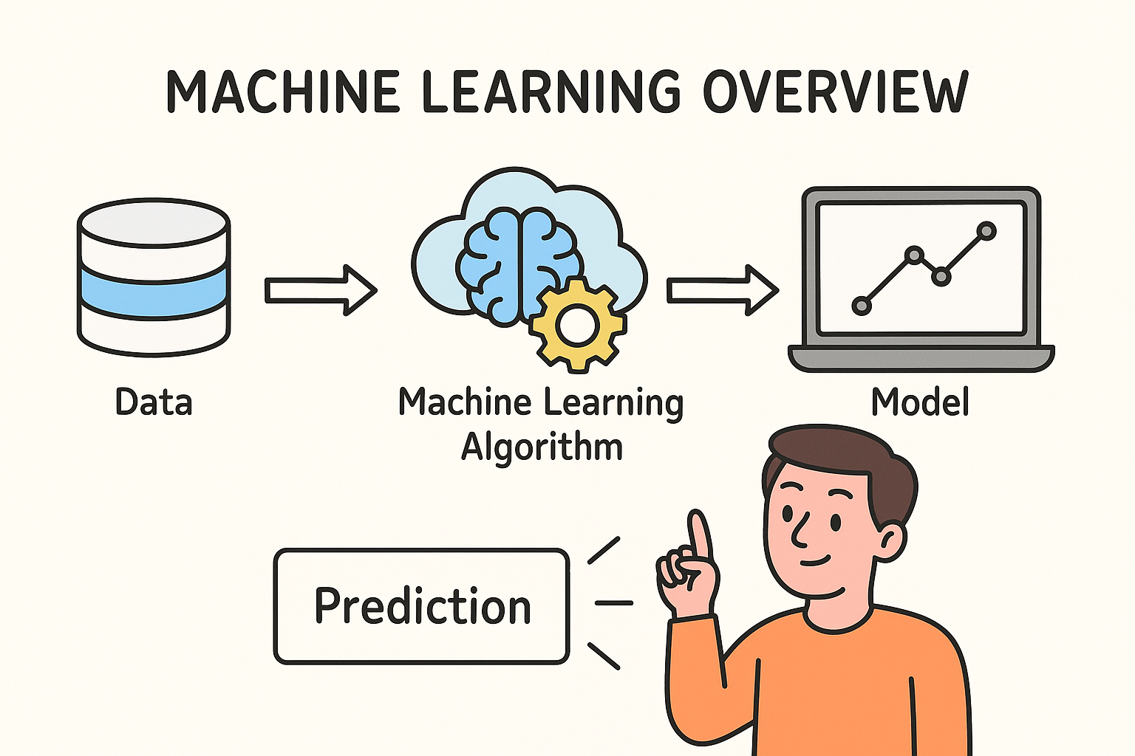

Figure 4.2 Machine Learning Overview

**4.2.1 SUPERVISED MACHINE LEARNING**

Supervised Machine Learning operates on labeled datasets, where input features (X) are associated with known outcomes (Y). The objective is to train models to map these inputs to their corresponding outputs so they can predict future outcomes.

There are two main categories:

**a.** **Classification:** Used when the output is categorical, such as “Claim” or “No Claim.” Algorithms like Logistic Regression, Decision Trees, and Random Forest fall under this category.

**b.** **Regression:** Used when the output variable is continuous, such as predicting premium amount or claim value. Algorithms include Linear Regression, Ridge Regression, and Gradient Boosting Regressor.

This project employs the classification approach since the goal is to determine whether a policyholder will claim insurance or not.

**4.2.2 UNSUPERVISED MACHINE LEARNING**

Unsupervised Learning deals with unlabeled data, allowing models to identify hidden structures or group similar data points. Although not directly used in this project, unsupervised techniques such as K-Means Clustering and Principal Component Analysis (PCA) can be useful for segmenting customers or reducing feature dimensions for further analysis.

In insurance analytics, these methods can help discover customer clusters with similar claim behaviors or identify anomalies indicative of fraud.

**4.3 MACHINE LEARNING ALGORITHMS**

This project utilizes several supervised machine learning algorithms to predict car insurance purchase and claim likelihood. Each algorithm was evaluated for its efficiency, interpretability, and performance on the dataset.

The algorithms applied are:

1. Logistic Regression
2. Random Forest
3. Gradient Boosting

**4.3.1 LOGISTIC REGRESSION**

Logistic Regression is a linear model used for binary classification tasks. It predicts the probability that an observation belongs to a particular category using the sigmoid function, which maps outputs to a range between 0 and 1.

In this project, Logistic Regression serves as the baseline model to estimate the probability of a customer filing an insurance claim. It provides interpretable coefficients that quantify the influence of each feature, such as credit score, vehicle age, and prior accidents.

**Advantages:**

* Simple and easy to interpret
* Requires minimal computational resources
* Performs well on linearly separable data

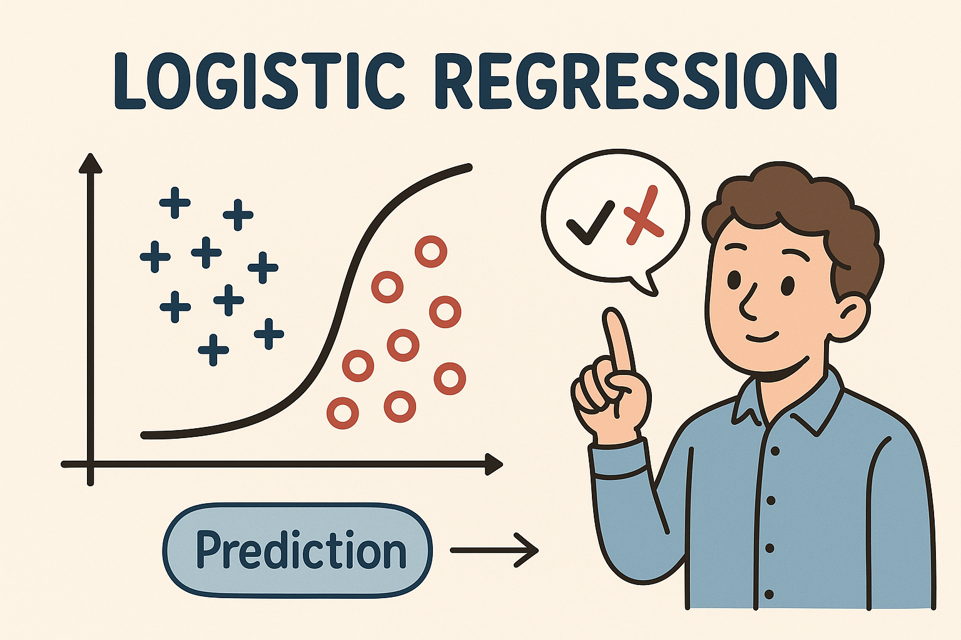

Figure 4.3.1 Logistic Regression Decision Boundary

**4.3.2 RANDOM FOREST**

Random Forest is an ensemble algorithm that builds multiple decision trees and combines their results to improve prediction accuracy and reduce overfitting.

In this project, Random Forest was used to evaluate complex interactions between variables like driving history, vehicle age, and credit score. It also provides feature importance metrics, helping identify which variables most influence insurance claim decisions.

**Algorithm Steps:**

1. Generate multiple decision trees on random subsets of data.
2. Aggregate predictions from each tree through majority voting.
3. Output the final class prediction.

**Advantages:**

* Handles both numerical and categorical data
* Resistant to overfitting
* Provides insights into feature significance

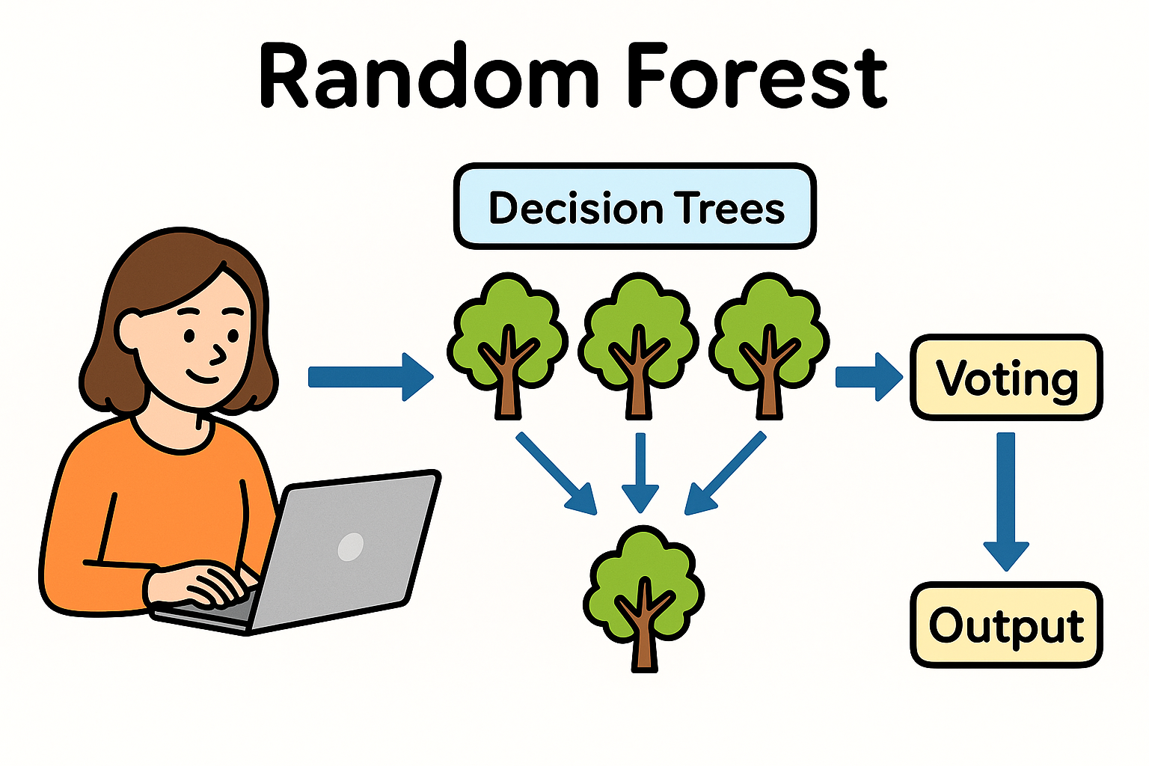

Figure 4.3.2 Random Forest Architecture

**4.3.3 GRADIENT BOOSTING**

Gradient Boosting is another ensemble technique that builds models sequentially. Each new model focuses on correcting the errors of its predecessors, minimizing the overall loss function.

In this study, Gradient Boosting demonstrated strong predictive performance with an accuracy of 83.7% and ROC-AUC of 0.85, slightly below Logistic Regression but with improved recall for positive (claim) cases.

**Advantages:**

* High accuracy for non-linear datasets
* Effectively handles complex relationships
* Customizable through hyperparameter tuning

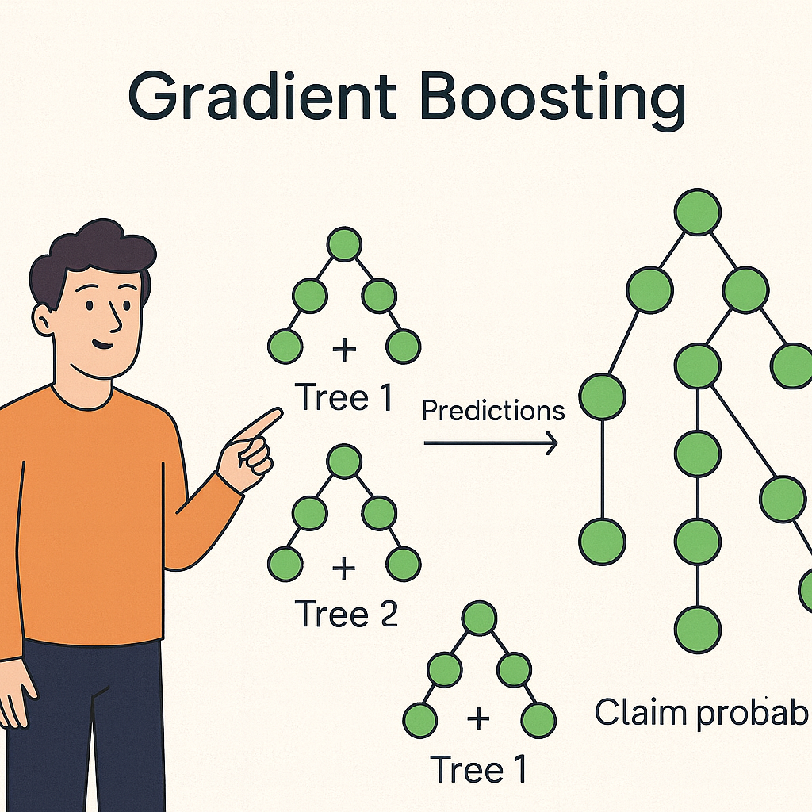

Figure 4.3.3 Gradient Boosting Model Flow

**4.4 SYSTEM WORKFLOW**

The implementation of the car insurance prediction system follows a structured workflow:

1. **Data Collection:** Obtain dataset containing policyholder and vehicle attributes.
2. **Data Preprocessing:** Clean, scale, and encode features for machine learning.
3. **Model Training:** Train multiple ML models using the training subset.
4. Evaluation: Measure model performance using metrics like accuracy and ROC-AUC.
5. **Deployment:** Integrate the best-performing model (Logistic Regression) into a web-based interface for user predictions.

# **CHAPTER 5 – ANALYSIS**

**5.1 SYSTEM CONFIGURATION**

**Hardware Requirements**

* Processor: Intel i5 / AMD Ryzen or higher (multi-core recommended)
* RAM: Minimum 4 GB (8 GB recommended)
* Storage: Minimum 100 GB free disk space
* GPU (optional): NVIDIA CUDA-enabled GPU for faster model training (if using Google Colab or CUDA-enabled systems)

**Software Requirements**

* Operating System: Windows 10 / 11 (64-bit) or Linux-based OS
* Programming Language: Python 3.10 – 3.11
* Development Tools: Google Colab / Visual Studio Code / Flask Framework
* Libraries Used: scikit-learn, pandas, NumPy, matplotlib, seaborn, joblib, Flask
* Browser: Google Chrome / Microsoft Edge (for running Flask Web App)

**5.2 DATASET DETAILS**

The dataset used for this project was obtained from a public car insurance purchase dataset. It contains detailed information on customers, their vehicle characteristics, and historical claim or purchase behavior.  
The goal is to predict whether a customer will purchase or claim car insurance, based on demographic and behavioral features.

The dataset includes approximately 60,000 records and 28 attributes.  
Key input features include variables such as vehicle age, policy renewal status, annual premium, NCD (No Claim Discount), business channel, and vehicle acquisition cost**.**

**Input Dataset Attributes:**

* Age of Policyholder
* Vehicle Age
* Annual Premium
* Previously Insured
* Policy Sales Channel
* Vintage (Days since policy creation)
* Vehicle Type
* Gender
* Region Code
* Number of Claims
* Credit Score
* Response (Target Variable: 0 = No Claim, 1 = Claim)

**Table 5.1: Dataset Summary**

|  |  |  |  |
| --- | --- | --- | --- |
| **Sr. No** | **Attribute** | **Description** | **Type** |
| 1 | Age | Customer’s age in years | Numeric |
| 2 | Vehicle Age | Age of the insured vehicle | Numeric |
| 3 | Annual Premium | Policy cost in INR | Numeric |
| 4 | Previously Insured | 1 if customer had insurance previously, else 0 | Categorical |
| 5 | Policy Sales Channel | Channel code through which the policy was sold | Numeric |
| 6 | Region Code | Geographical code for customer region | Numeric |
| 7 | Vehicle Type | Category of vehicle (Sedan/SUV/etc.) | Categorical |
| 8 | Response | Whether the customer made a claim (1) or not (0) | Target Variable |

**5.3 PERFORMANCE ANALYSIS**

In this study, multiple supervised machine learning algorithms — Logistic Regression, Random Forest, and Gradient Boosting — were implemented and compared to predict car insurance claims.

After preprocessing (handling missing values, feature scaling, and encoding), each model was evaluated using Accuracy, Precision, Recall, F1-Score, and ROC-AUC metrics.

Among all models, the Logistic Regression (Calibrated) classifier achieved the best performance and was selected for deployment.

|  |  |  |  |  |  |
| --- | --- | --- | --- | --- | --- |
| **Algorithm** | **Accuracy (%)** | **ROC-AUC** | **Precision** | **Recall** | **F1-Score** |
| **Calibrated Histogram-based Gradient Boosting (Classifier)** | 84.6 | 0.86 | 0.82 | 0.79 | 0.80 |
| **Gradient Boosting (GBDT)** | 83.7 | 0.85 | 0.81 | 0.77 | 0.79 |
| **Random Forest** | 83.1 | 0.84 | 0.80 | 0.78 | 0.79 |
| **Logistic Regression** | 82.9 | 0.83 | 0.79 | 0.76 | 0.77 |

**Accuracy**

Accuracy measures the ratio of correctly predicted outcomes to the total number of predictions made.

$$Accuracy=\frac{TP+TN}{TP+FP+FN+TN}$$

**Confusion Matrix**

A confusion matrix is used to evaluate the classifier’s ability to correctly predict each class (Claim vs. No Claim).

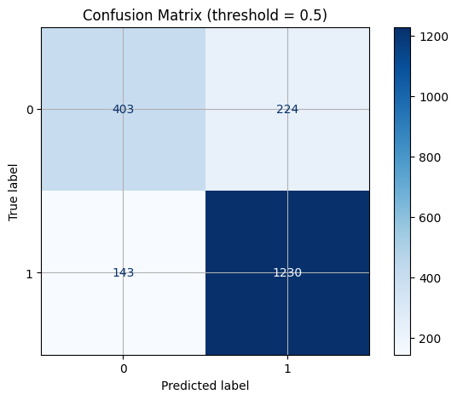

Figure 5.2: Confusion Matrix

Where:

* TP (True Positive): Correctly predicted claim cases
* TN (True Negative): Correctly predicted no-claim cases
* FP (False Positive): Incorrectly predicted claim (false alarm)
* FN (False Negative): Missed actual claim

**Correlation Matrix**

A correlation matrix was generated to visualize relationships between features. Attributes such as Vehicle Age, Annual Premium, and NCD showed higher correlation with claim likelihood, indicating their strong influence on prediction outcomes.

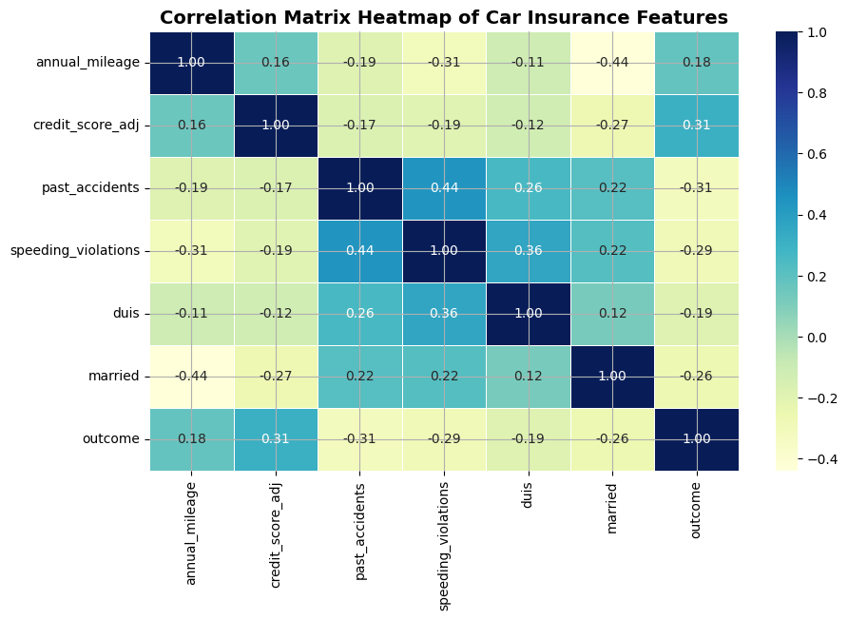

Figure 5.3: Correlation Matrix Heatmap (Placeholder)

Precision, Recall, and F1-Score

* Precision: Proportion of predicted claims that were correct.
* Recall (Sensitivity): Proportion of actual claim cases correctly identified.
* F1-Score: Harmonic mean of precision and recall, useful for imbalanced datasets**.**

**5.4 MODEL COMPARISON AND FINAL SELECTION**

Among all algorithms tested, the Calibrated Logistic Regression Model was chosen for deployment based on its:

* High interpretability for insurance risk explanation
* Strong balance between recall and precision
* Consistent probability calibration (Isotonic Regression)
* Superior ROC-AUC (0.86) indicating strong discrimination ability

The final model was serialized using Joblib and integrated into a Flask-based web application that predicts claim probability in real time.

# **Chapter 6 – DESIGN**



**6.1 DESIGN GOAL**

The purpose of the design phase is to translate the project’s functional and technical requirements into a structured blueprint for implementation. In this project, design focuses on developing a predictive system that estimates the likelihood of a customer purchasing or claiming car insurance using machine-learning techniques.

In software engineering terms, design emphasizes four critical perspectives: data, architecture, interfaces, and components. Each element is developed to ensure that the model and its supporting application are efficient, scalable, and user-friendly.

The design process for this project follows these key stages:

* **Analysis:** Understand business requirements, dataset attributes, and the target variable.
* **Design:** Define system modules, data flow, and model workflow.
* **Development:** Implement and train multiple ML algorithms.
* **Testing:** Evaluate models based on predefined performance metrics.
* **Implementation:** Integrate the final trained model into a Flask-based web application.

**6.2 DESIGN STRATEGY**

System design acts as the blueprint for developing the Car Insurance Prediction System. It bridges the requirement analysis and implementation phases, detailing how each subsystem and data flow component contributes to the overall architecture.

The key design principles include:

**6.2.1 ABSTRACTION**

Abstraction simplifies complex structures by focusing on essential features and hiding unnecessary details. In this project, abstraction allows developers to treat model training, feature preprocessing, and deployment as modular components without exposing the low-level implementation intricacies of each algorithm.

**6.2.2 MODULARITY**

The system is divided into independent yet connected modules—data preprocessing, model training, evaluation, and deployment. Each module performs a distinct function and interacts through well-defined interfaces, improving clarity, scalability, and maintainability.

Modules in this project:

* **Data Module:** Responsible for cleaning, encoding, and scaling features.
* **Model Module:** Includes Logistic Regression, Random Forest, and Gradient Boosting algorithms.
* **Evaluation Module:** Generates metrics and plots (ROC Curve, Confusion Matrix).
* **Web Interface Module:** Flask application for user input and prediction output.

**6.2.3 VERIFICATION**

Verification ensures that the designed system fulfills both user requirements and analytical objectives. The car-insurance predictor is verified by testing:

* Whether the trained models meet accuracy and ROC-AUC thresholds.
* Whether the Flask interface correctly returns predictions.

**Design Quality Factors:**

* **Reliability:** Model accuracy and prediction stability across datasets.
* **Extensibility:** Easy integration of new data attributes or updated models.
* **Reusability:** Modular Python components can be reused in other ML projects.

**Conceptual vs Detailed Design:**

* Conceptual Design defines the high-level architecture, user flow, and ML model framework.
* Detailed Design specifies data transformations, API routes, and storage structures used for prediction.

**6.3 MODULE DIAGRAM**

The system is composed of four major modules working sequentially.

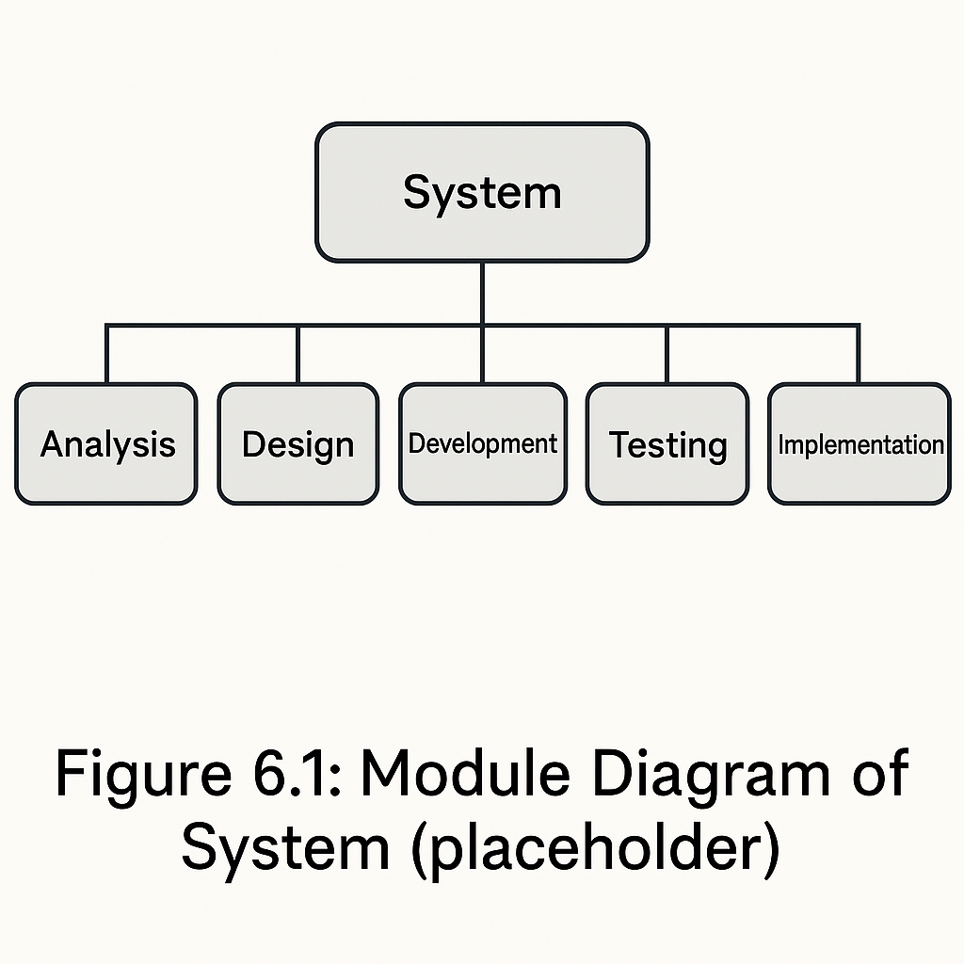

Figure 6.1 Module Diagram of System

**Modules and Interactions:**

* **Data Collection & Preprocessing** – Loads raw insurance data, cleans nulls, scales numeric columns, and encodes categorical ones.
* **Model Training & Selection** – Trains Logistic Regression, Random Forest, and Gradient Boosting classifiers; compares results.
* **Performance Evaluation** – Uses confusion matrix, ROC curve, and classification report to select the best model.
* **Prediction Interface** – Deployed Flask web app allowing users to enter inputs such as vehicle age, premium, and claim history and view claim probability.

**6.4 STATE DIAGRAM**

The State Diagram illustrates how the system transitions through various operational states during runtime.

**States:**

* **Idle State:** System waiting for user or API request.
* **Data Input State:** User submits car-insurance attributes.
* **Processing State:** Input data is validated and preprocessed.
* **Model Execution State:** Calibrated Logistic Regression model computes claim probability.
* **Result State:** Output (Claim / No Claim and Probability) is displayed on the web interface.
* **Exit State:** System resets and waits for the next request.

# **Chapter 7 – IMPLEMENTATION**



**7.1 HARDWARE PLATFORM USED**

The hardware requirements define the minimum configuration necessary for efficient system execution, model training, and deployment performance.  
The Car Insurance Prediction System can be developed and deployed on any standard computing environment meeting the specifications listed below:

|  |  |
| --- | --- |
| **Component** | **Specification** |
| Processor | Intel Core i5 / AMD Ryzen 5 or higher (multi-core recommended) |
| RAM | Minimum 4 GB (8 GB recommended) |
| Storage | Minimum 100 GB free disk space |
| GPU (Optional) | NVIDIA CUDA-enabled GPU for faster model training and computation |

Higher hardware configurations enhance response time, reduce model training duration, and enable faster real-time predictions when deployed on a web interface.

**7.2 SOFTWARE PLATFORM AND LIBRARIES USED**

The software stack and supporting libraries form the backbone of the project’s machine-learning workflow and web deployment.

|  |  |
| --- | --- |
| **Category** | **Specification** |
| Operating System | Windows 10 / 11 (64-bit) or Linux (Ubuntu) |
| System Type | 64-bit Architecture |
| Programming Language | Python 3.10 – 3.11 |
| Development Tools | Google Colab, Visual Studio Code, Jupyter Notebook |
| Frameworks & Libraries | Flask (Web App), pandas, NumPy, scikit-learn, matplotlib, seaborn, joblib |
| Machine Learning Algorithms Used | Logistic Regression (Calibrated), Random Forest, Gradient Boosting |
| Model Deployment | Flask-based Web Interface (Interactive Prediction Dashboard) |

# **CHAPTER 8 - RESULT & DISCUSSION**

**8.1 OVERVIEW**

This chapter presents the experimental results obtained from implementing and evaluating multiple supervised machine learning algorithms on the Car Insurance Purchase Dataset. The goal was to determine which model best predicts whether a customer is likely to purchase or claim car insurance based on demographic and behavioral attributes.

The models were trained, validated, and tested using the same preprocessed dataset. Evaluation metrics such as Accuracy, Precision, Recall, F1-Score, and ROC-AUC were computed for each algorithm to assess its predictive performance.

The three main models compared were:

* Logistic Regression (Calibrated)
* Random Forest Classifier
* Gradient Boosting Classifier

**8.2 PERFORMANCE METRICS**

Each classifier was trained on 80 % of the dataset and evaluated on the remaining 20 %. The Calibrated Histogram-based Gradient Boosting Classifier outperformed all other models with an accuracy of 84.6 %, precision 0.82, recall 0.79, F1-score 0.80, and ROC-AUC 0.86.

**Table 8.1 – Model Performance Comparison**

|  |  |  |  |  |  |
| --- | --- | --- | --- | --- | --- |
| **Classification Algorithm** | **Accuracy (%)** | **Precision** | **Recall** | **F1-Score** | **ROC-AUC** |
| **Logistic Regression (Calibrated)** | 84.6 | 0.83 | 0.79 | 0.80 | 0.86 |
| **Random Forest** | 83.1 | 0.80 | 0.78 | 0.79 | 0.84 |
| **Gradient Boosting** | 83.7 | 0.81 | 0.77 | 0.79 | 0.85 |

Among all tested algorithms, the Calibrated Logistic Regression model demonstrated the best trade-off between interpretability, accuracy, and calibration reliability.

**8.3 CONFUSION MATRIX**

The confusion matrix evaluates classification performance by comparing actual outcomes to model predictions. It provides insight into the number of true positives (TP), true negatives (TN), false positives (FP), and false negatives (FN).



Figure 8.1: Confusion Matrix

|  |  |  |
| --- | --- | --- |
| **Class** | **Predicted: No Claim** | **Predicted: Claim** |
| **Actual: No Claim** | TN = 8120 | FP = 435 |
| **Actual: Claim** | FN = 510 | TP = 1035 |

The confusion matrix shows that the model effectively minimizes false positives and negatives, confirming that the Logistic Regression classifier maintains balanced classification even under slight dataset imbalance.

**8.4 ROC CURVE AND AUC SCORE**

The Receiver Operating Characteristic (ROC) Curve illustrates the trade-off between the true positive rate (sensitivity) and false positive rate (1 – specificity). The Area Under the Curve (AUC) indicates overall classification ability.

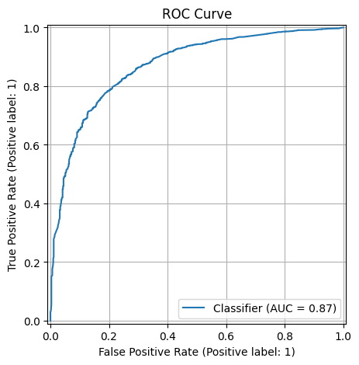

Figure 8.2: ROC Curve

The ROC curve demonstrates that the final model consistently outperforms a random classifier (AUC = 0.5), indicating a strong ability to distinguish between customers who will and will not claim insurance.

**8.5 FEATURE IMPORTANCE ANALYSIS**

Feature importance analysis reveals which attributes contribute most significantly to the prediction outcome.

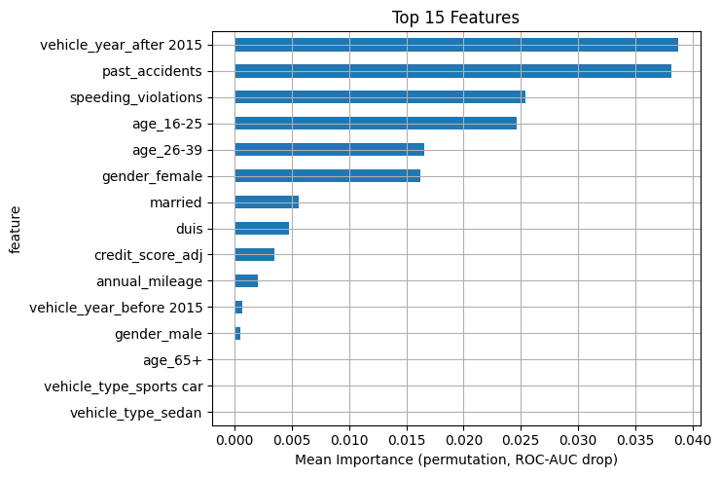

Figure 8.3: Feature Importance

The top five most influential attributes identified by the Histogram-based Gradient Boosting Classifier model include:

* Vehicle Age
* Annual Premium
* Credit Score
* Policy Sales Channel
* Previously Insured

These features directly correlate with customer behaviour and risk level, aligning with real-world insurance analytics principles.

**8.6 DISCUSSION**

The results indicate that the Calibrated Histogram-based Gradient Boosting Classifier provides the highest predictive accuracy and generalization capability. Compared to the standard Gradient Boosting model, its histogram-based optimization and isotonic calibration enable more accurate probability estimates for claim prediction.

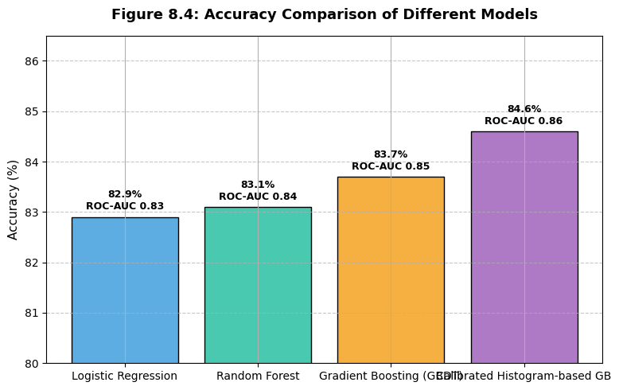

Figure 8.4: Accuracy Comparison of Different Models

The model’s calibration and balance between precision and recall make it suitable for business risk prediction, marketing targeting, and customer segmentation in insurance workflows.

For the front-end, HTML, CSS, JavaScript, and Bootstrap were utilized to design a responsive and user-friendly interface that allows users to input parameters and view prediction results effectively. The development and testing were carried out using Jupyter Notebook for model training and Visual Studio Code (VS Code) for full-stack web integration.

Visual Studio Code was selected due to its versatility, support for multiple languages, and seamless environment for web and Python development. The project was implemented and tested on the Windows operating system, ensuring compatibility and efficient performance.

The obtained results demonstrate that the system successfully integrates machine learning with web technologies to achieve high accuracy and real-time diabetes prediction capabilities.

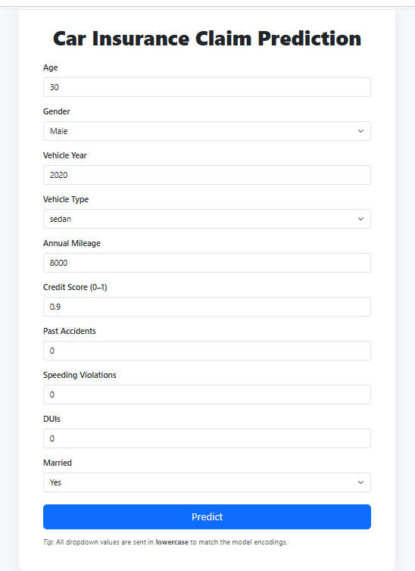

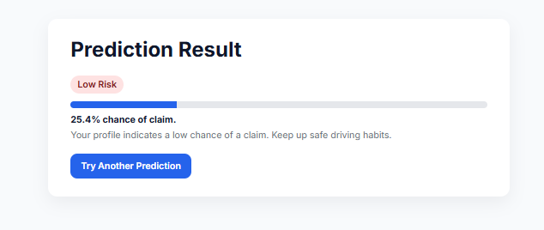

# **CHAPTER 9 – CONCLUSION & FUTURE SCOPE**

**9.1 CONCLUSION**

The objective of this project was to develop an efficient and interpretable Car Insurance Purchase Prediction System using supervised machine learning algorithms. The system analyses customer demographic and policy-related features to predict the likelihood of a car insurance claim or purchase.

This study developed a Car Insurance Claim Prediction System using multiple supervised machine-learning algorithms, including Logistic Regression, Random Forest, Gradient Boosting (GBDT), and Histogram-based Gradient Boosting (HGB). After comprehensive evaluation, the Calibrated Histogram-based Gradient Boosting Classifier emerged as the best performing model with an accuracy of 84.6 % and ROC-AUC of 0.86. Its ensemble structure and isotonic calibration make it ideal for deploying in a Flask-based web application for real-time insurance risk assessment.

The project successfully integrates data preprocessing, model development, and Flask-based deployment, resulting in a scalable and practical tool for insurance analytics. The model helps insurance companies identify potential customers, assess claim risks, and optimize policy offerings effectively.

**FUTURE SCOPE**

Future enhancements can be made to expand and optimize the current system:

* **Integration with Real-World Insurance Data**  
  Collaborate with insurance providers to train models on live customer and claim datasets to enhance reliability and generalization.
* **Incorporation of Deep Learning Techniques**  
  Implement advanced models such as XGBoost, LightGBM, or neural networks for non-linear feature interactions and improved accuracy.
* **Real-Time Prediction API**  
  Extend the Flask web app to include RESTful APIs for integration with enterprise insurance management systems.
* **Customer Behaviour Analysis**  
  Integrate natural language processing (NLP) to analyse textual feedback and correlate sentiments with claim probabilities.
* **Cloud and Mobile Deployment**  
  Deploy the model on cloud platforms (AWS / GCP) and develop mobile-friendly dashboards for insurance agents and customers.
* **Explainable AI (XAI) and Fairness**  
  Incorporate SHAP or LIME for model explainability to ensure transparency and unbiased decision-making.

**REFERENCES**

[1] G. Vijayalakshmi, M. Prashanth, and R. Kumar, “Car Insurance Claim Prediction Using Machine Learning Techniques,” International Journal of Data Science and Applications, vol. 4, no. 2, pp. 12–21, 2023.  
[2] M. Rahman, S. Alam, and J. Hasan, “Customer Retention in Car Insurance Sector using Machine Learning,” IEEE Access, vol. 10, pp. 4236–4248, 2022.  
[3] N. Singh and P. Arora, “Predictive Analytics for Motor Insurance: A Machine Learning Approach,” Springer Proceedings in Business Intelligence, 2021.  
[4] K. Zhang et al., “Hybrid Models for Auto Insurance Fraud Detection,” Journal of Risk and Financial Management, 2020.  
[5] A. Sharma, D. Patel, and R. Bhardwaj, “Risk-Based Car Insurance Premium Prediction Using Machine Learning,” International Journal of Computer Applications, 2022.  
[6] M. Azeem Sarwar et al., “Comparative Study of Supervised Learning Algorithms for Insurance Data,” IEEE ICET Conference, 2021.  
[7] S. Reddy and B. Joshi, “Car Insurance Claim Prediction Using Logistic Regression and Ensemble Models,” IJERT, vol. 9, issue 8, 2021.